**Boost converter operation**

1. Under the condition same as the buck converter, the boost converter operate in continuous conduction mode.

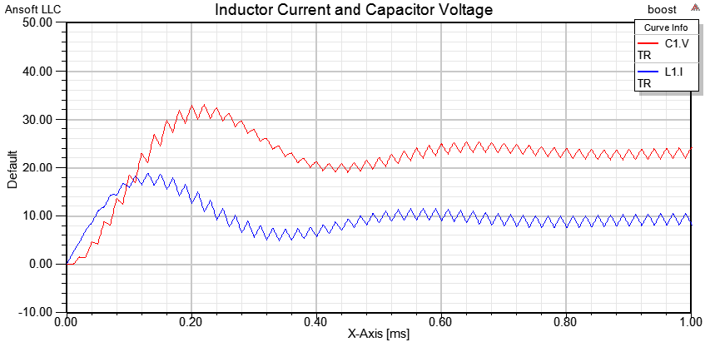

The boost converter will operate in discontinuous conduction mode if the ripple current is larger than the twice of the inductor current. The inductor current can be determent by the load since input power is equal to the output power if there is not loss. The output voltage can be calculated by:

Vout = Vdc/(1-D)

The output voltage in this case is 24V and the load is 5 ohms. By ohms law, the output current is 4.8A. The output power is 115.2W; the input power must also be 115.2W. The input voltage is 12V so the current input is 9.6A. The inductor current in a boost converter is the same as the input current. The ripple current can be calculated by:

ΔI = VdcD/LF = 12 x0.5/[(50x10^-6)(50x10^3) = 2.4A

The ripple current is 2.4A which is smaller the twice of the inductor current, the converter should work in continuous conduction mode.

1. The Vo is 24V and it is make sense because Vout = Vdc/(1-D).
2. The inductor current drop down to 1.2A, the converter will fill on the borderline between CCM and DCM. In this condition, the load current would be 0.6A. The output resistance would be 40 ohms.

Here is the result of simulation with load resistance of 40 ohms with initial condition Inductor current 1.2A and capacitor voltage 24V:



1. If the load resistance is 5 ohms, the load current will be 4.8A and the inductor current would be 9.6A. If we want to push the converter to operate on the borderline between CCM and DCM, the current ripple would be at least 19.2A. The inductance of the inductor can be determent by:

ΔI = VdcD/LF, L = VdcD/ΔI F = 12x0.5/[19.2x(50x10^3)] = 6.25 uH.

The inductance would be 6.25 uH.

Here is the result of simulation with inductance of 6.25 uH and initial condition Inductor current 9.6A and capacitor voltage 24V:



1. When we change the duty cycle of the converter, the voltage change. When the duty cycle is 0.2, the voltage output becomes 15V. When we change the duty cycle to 0.8, the voltage output becomes 60V.

Here is the result of simulation 0.2 duty cycle and initial condition Inductor current 0A and capacitor voltage 0V:



Here is the result of simulation 0.8 duty cycle and initial condition Inductor current 60A and capacitor voltage 60V:

